Oblique Wedge

Definition
# Source: AI Source: Provided by: [Data Path: Persons Table -> ID Column: 1, Name_En Column: Motasem Essam] -> From: [ChatGPT] on [7/25/2026]
An Oblique Wedge is a three-dimensional wedge-shaped solid in which the connecting edges between its two parallel end faces are inclined rather than perpendicular to the planes of those faces.
In a triangular oblique wedge, the two triangular end faces are parallel and congruent, while the lateral faces are generally parallelograms.
Unlike a right wedge, its lengthwise connecting edges are not perpendicular to the triangular end faces.
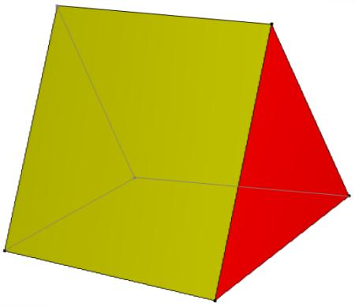
<caption>Oblique wedge – the connecting edges are inclined relative to the end faces.</caption>

Simple Definition
# Source: AI Source: Provided by: [Data Path: Persons Table -> ID Column: 1, Name_En Column: Motasem Essam] -> From: [ChatGPT] on [7/25/2026]
An oblique wedge is a wedge-shaped solid whose connecting edges are inclined to the planes of its parallel end faces rather than perpendicular to them.

Geometric Structure
# Source: AI Source: Provided by: [Data Path: Persons Table -> ID Column: 1, Name_En Column: Motasem Essam] -> From: [ChatGPT] on [7/25/2026]
An oblique triangular wedge consists of three main structural components:
- First triangular face: One triangular end of the solid.
- Second triangular face: A congruent triangular end parallel to the first.
- Three inclined lateral faces: Connect the corresponding edges of the two triangular faces.
The connecting edges are inclined, giving the solid its characteristic slanted appearance.
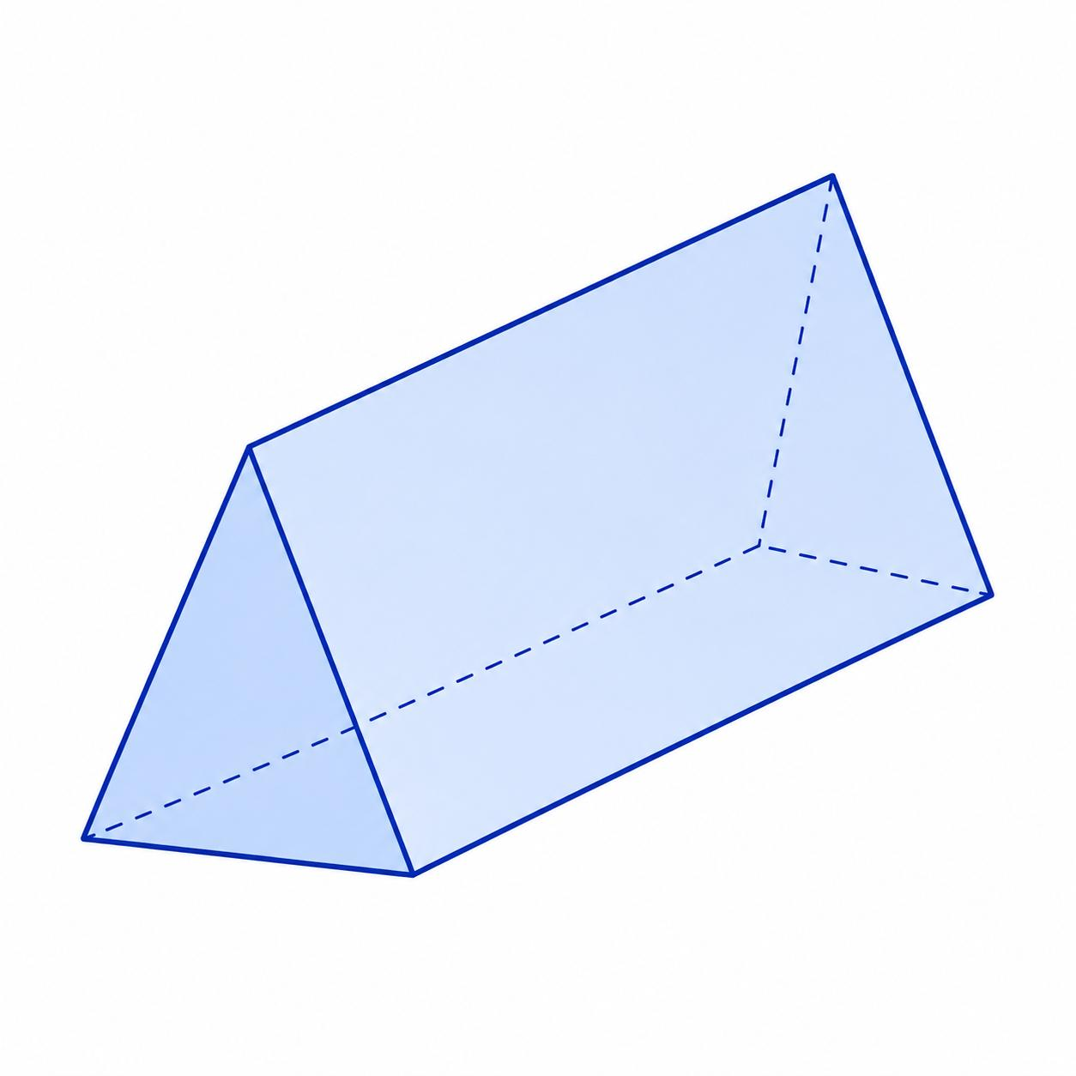

Face Structure
# Source: AI Source: Provided by: [Data Path: Persons Table -> ID Column: 1, Name_En Column: Motasem Essam] -> From: [ChatGPT] on [7/25/2026]
A standard polyhedral wedge has 5 faces.
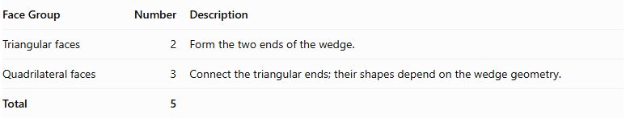
Face Group | Number | Description
Triangular faces | 2 | Form the two ends of the wedge.
Quadrilateral faces | 3 | Connect the triangular ends; their shapes depend on the wedge geometry.
Total | 5
In an oblique wedge, the lateral faces are arranged obliquely rather than forming the perpendicular arrangement of a right wedge.
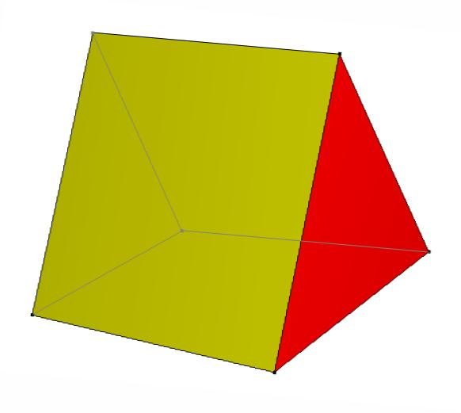

Edge Structure
# Source: AI Source: Provided by: [Data Path: Persons Table -> ID Column: 1, Name_En Column: Motasem Essam] -> From: [ChatGPT] on [7/25/2026]
An oblique wedge has 9 edges.
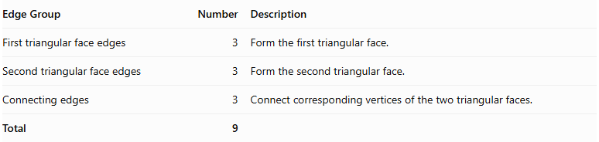
Edge Group | Number | Description
First triangular face edges | 3 | Form the first triangular face.
Second triangular face edges | 3 | Form the second triangular face.
Connecting edges | 3 | Connect corresponding vertices of the two triangular faces.
Total | 9

Vertex Structure
# Source: AI Source: Provided by: [Data Path: Persons Table -> ID Column: 1, Name_En Column: Motasem Essam] -> From: [ChatGPT] on [7/25/2026]
An oblique wedge has 6 vertices.
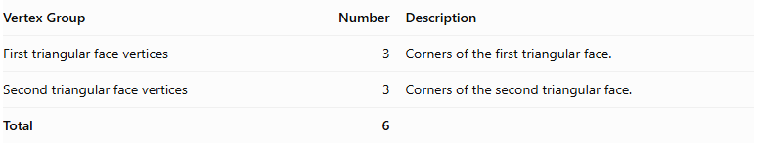
Vertex Group | Number | Description
First triangular face vertices | 3 | Corners of the first triangular face.
Second triangular face vertices | 3 | Corners of the second triangular face.
Total | 6

Mathematical Properties
# Source: AI Source: Provided by: [Data Path: Persons Table -> ID Column: 1, Name_En Column: Motasem Essam] -> From: [ChatGPT] on [7/25/2026]
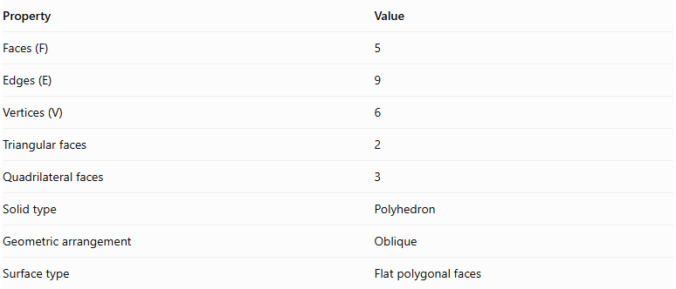
Property | Value
Faces (F) | 5
Edges (E) | 9
Vertices (V) | 6
Triangular faces | 2
Quadrilateral faces | 3
Solid type | Polyhedron
Geometric arrangement | Oblique
Surface type | Flat polygonal faces
It satisfies Euler's polyhedron formula:
$$V-E+F=2$$
Substituting:
$$6-9+5=2$$
Therefore, the oblique wedge satisfies Euler's formula.

Surface Area
# Source: AI Source: Provided by: [Data Path: Persons Table -> ID Column: 1, Name_En Column: Motasem Essam] -> From: [ChatGPT] on [7/25/2026]
The total surface area is the sum of the areas of all five faces.
$$\boxed{S=A_{1}+A_{2}+A_{3}+A_{4}+A_{5}}$$
Where:
- $A_{1},A_{2}$ = areas of the two triangular faces.
- $A_{3},A_{4},A_{5}$ = areas of the three quadrilateral faces.
The area of a triangle is:
$$A_{t}=\frac{1}{2}bh$$
For a trapezoidal face:
$$A_{\text{trap}}=\frac{1}{2}(a+b)h$$
The exact surface area depends on the dimensions and shapes of the individual faces.

Volume
# Source: AI Source: Provided by: [Data Path: Persons Table -> ID Column: 1, Name_En Column: Motasem Essam] -> From: [ChatGPT] on [7/25/2026]
For the standard oblique wedge configuration described by Wolfram MathWorld, the volume is:
$$\boxed{V=\frac{1}{6}bh(2a+c)}$$
Where:
- $a$ = length of the lower edge.
- $b$ = width of the rectangular base.
- $c$ = length of the upper edge parallel to $a$.
- $h$ = perpendicular height between the base and upper edge.
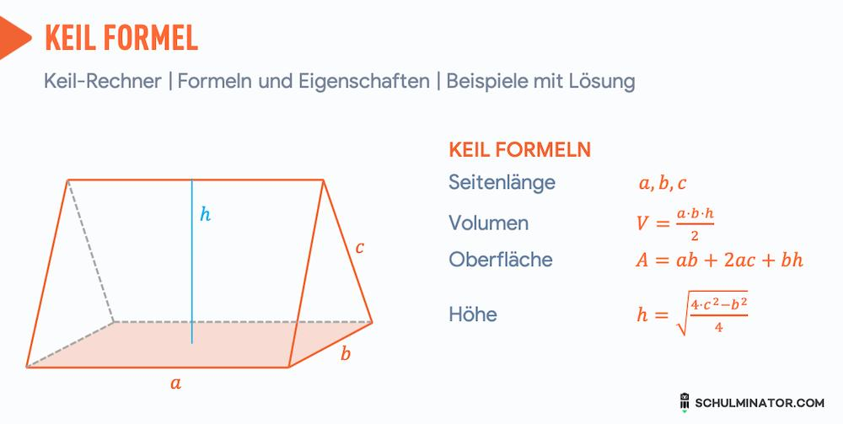
For a right wedge, where $c=a$, the formula becomes:
$$V=\frac{1}{6}bh(2a+a)$$
Therefore:
$$\boxed{V=\frac{1}{2}abh}$$
This shows the relationship between the standard right and oblique wedge configurations.

Symmetry
# Source: AI Source: Provided by: [Data Path: Persons Table -> ID Column: 1, Name_En Column: Motasem Essam] -> From: [ChatGPT] on [7/25/2026]
The symmetry of an oblique wedge depends on its dimensions and geometric arrangement.
- Oblique arrangement: Its upper edge or connecting structure is inclined rather than perpendicular to the base.
- Reflection symmetry: May exist if the wedge is constructed symmetrically.
- Rotational symmetry: A general oblique wedge does not have rotational symmetry.
- Right-angle relationship: Unlike a right wedge, its inclined structure does not have the same perpendicular arrangement.
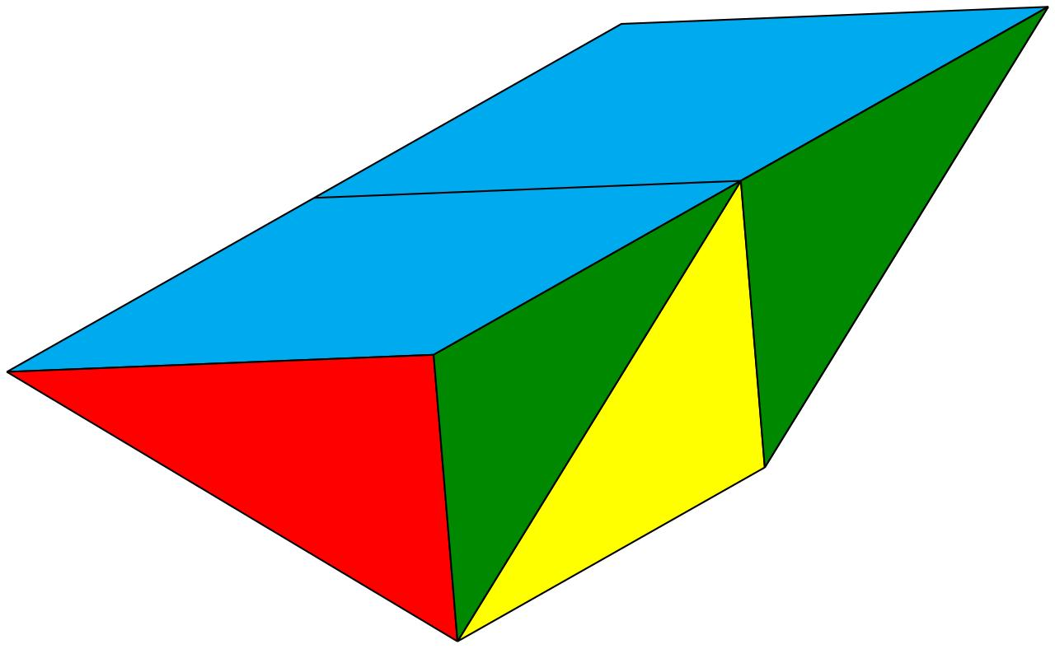

Relationship to Other Solids
# Source: AI Source: Provided by: [Data Path: Persons Table -> ID Column: 1, Name_En Column: Motasem Essam] -> From: [ChatGPT] on [7/25/2026]
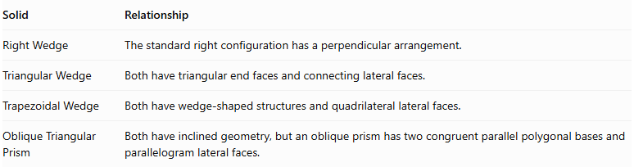
Solid | Relationship
Right Wedge | The standard right configuration has a perpendicular arrangement.
Triangular Wedge | Both have triangular end faces and connecting lateral faces.
Trapezoidal Wedge | Both have wedge-shaped structures and quadrilateral lateral faces.
Oblique Triangular Prism | Both have inclined geometry, but an oblique prism has two congruent parallel polygonal bases and parallelogram lateral faces.
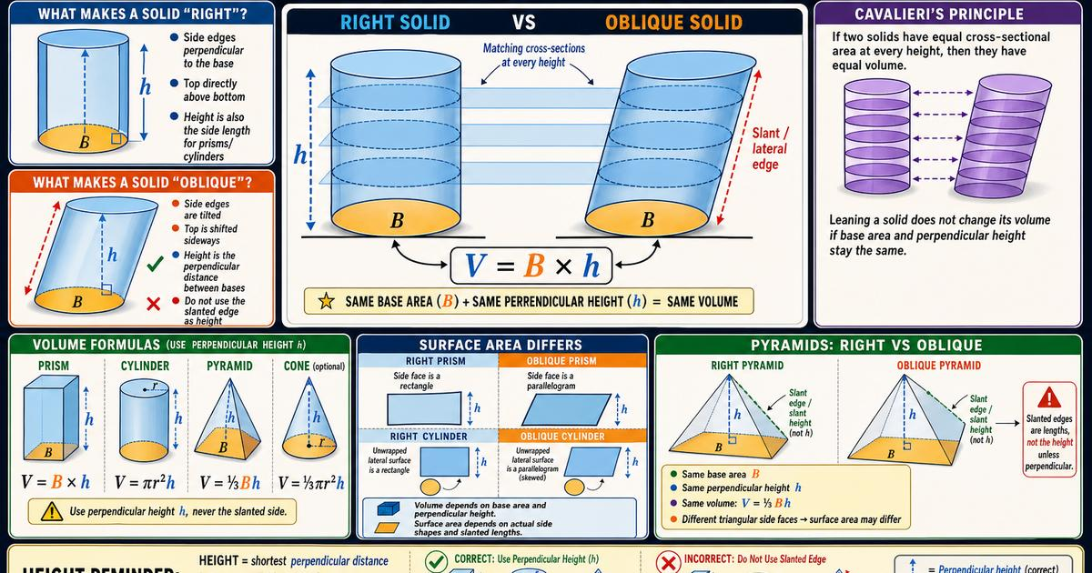

Worked Examples

Example 1: Calculate Faces, Edges, and Vertices
# Source: AI Source: Provided by: [Data Path: Persons Table -> ID Column: 1, Name_En Column: Motasem Essam] -> From: [ChatGPT] on [7/25/2026]
An oblique wedge has:
- 2 triangular faces.
- 3 quadrilateral faces.
- 9 edges.
- 6 vertices.
Therefore:
$$F=2+3=5$$
$$E=9$$
$$V=6$$

Example 2: Calculate Volume
# Source: AI Source: Provided by: [Data Path: Persons Table -> ID Column: 1, Name_En Column: Motasem Essam] -> From: [ChatGPT] on [7/25/2026]
Given:
- $a=9\text{ cm}$
- $b=4\text{ cm}$
- $c=3\text{ cm}$
- $h=6\text{ cm}$
Using:
$$V=\frac{1}{6}bh(2a+c)$$
Substituting:
$$V=\frac{1}{6}(4)(6)(2(9)+3)$$
$$V=4(21)$$
$$\boxed{V=84{\text{ cm}}^{3}}$$

Constructing Oblique Wedge in Solid Geometry

Geometric Instruments Used
# Source: AI Source: Provided by: [Data Path: Persons Table -> ID Column: 1, Name_En Column: Motasem Essam] -> From: [ChatGPT] on [7/25/2026]

- Ruler: Drawing straight edges.
- Compass: Drawing arcs and transferring distances.
- Protractor: Measuring inclination angles.
- Set square: Constructing perpendicular and parallel lines.
- Pencil: Drawing construction lines.
- Eraser: Removing unnecessary construction marks.

Instrument-Based Construction Procedures

A. Constructing the Base
# Source: AI Source: Provided by: [Data Path: Persons Table -> ID Column: 1, Name_En Column: Motasem Essam] -> From: [ChatGPT] on [7/25/2026]
- Draw a rectangular base using a ruler.
- Mark its four corners.
- Establish the required base dimensions.
- Complete the rectangular outline.

B. Constructing the Upper Edge
# Source: AI Source: Provided by: [Data Path: Persons Table -> ID Column: 1, Name_En Column: Motasem Essam] -> From: [ChatGPT] on [7/25/2026]
- Identify the required height of the wedge.
- Mark the upper edge above the rectangular base.
- Shorten the upper edge according to the required dimensions.
- Position it to create an oblique arrangement.

C. Constructing the Lateral Faces
# Source: AI Source: Provided by: [Data Path: Persons Table -> ID Column: 1, Name_En Column: Motasem Essam] -> From: [ChatGPT] on [7/25/2026]
- Connect the endpoints of the upper edge to the appropriate base vertices.
- Draw the two triangular faces.
- Construct the remaining quadrilateral faces.
- Check that the connecting edges follow the intended inclined arrangement.

D. Completing the Oblique Wedge
# Source: AI Source: Provided by: [Data Path: Persons Table -> ID Column: 1, Name_En Column: Motasem Essam] -> From: [ChatGPT] on [7/25/2026]
- Check the proportions of the solid.
- Ensure that its upper structure is inclined.
- Darken the visible edges.
- Draw hidden edges using dashed lines when necessary.
- Remove unnecessary construction marks.
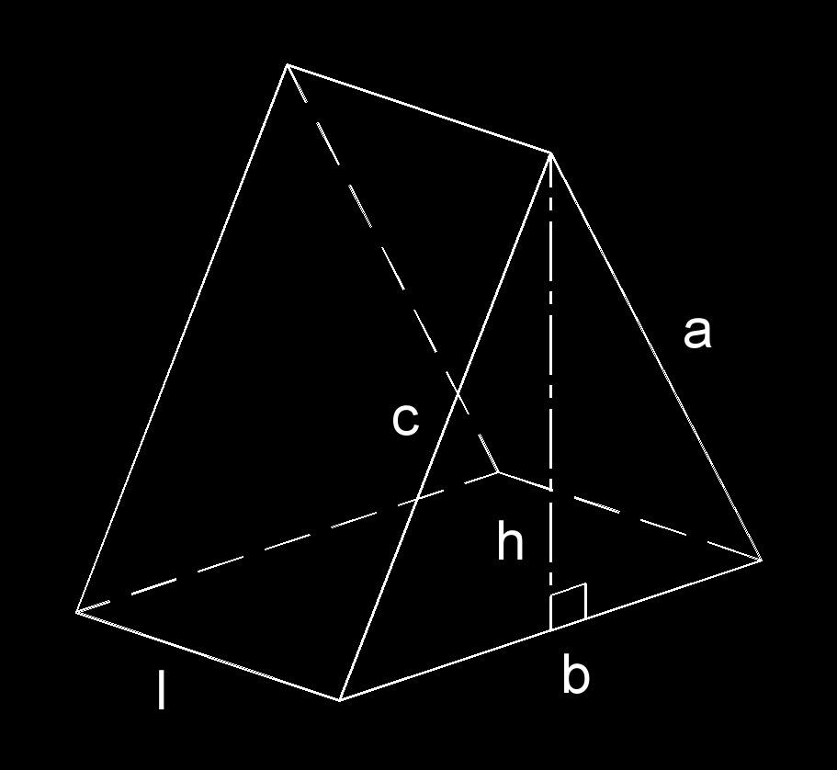

Key Points
# Source: AI Source: Provided by: [Data Path: Persons Table -> ID Column: 1, Name_En Column: Motasem Essam] -> From: [ChatGPT] on [7/25/2026]
- An oblique wedge is a three-dimensional polyhedron.
- Its geometric arrangement is inclined rather than perpendicular.
- The standard polyhedral wedge has 2 triangular faces and 3 quadrilateral faces.
- It has 5 faces in total.
- It has 9 edges.
- It has 6 vertices.
- Its surface area is the sum of its five face areas.
- Its volume depends on its dimensions and can be calculated using the oblique wedge formula.

Conclusion
# Source: AI Source: Provided by: [Data Path: Persons Table -> ID Column: 1, Name_En Column: Motasem Essam] -> From: [ChatGPT] on [7/25/2026]
An Oblique Wedge is a three-dimensional geometric solid characterized by an inclined arrangement of its faces and edges. In the standard polyhedral wedge model, it has two triangular faces, three quadrilateral faces, five faces in total, nine edges, and six vertices.
Its defining characteristic is its oblique geometric arrangement, distinguishing it from the right wedge.

